TC-CMS-032

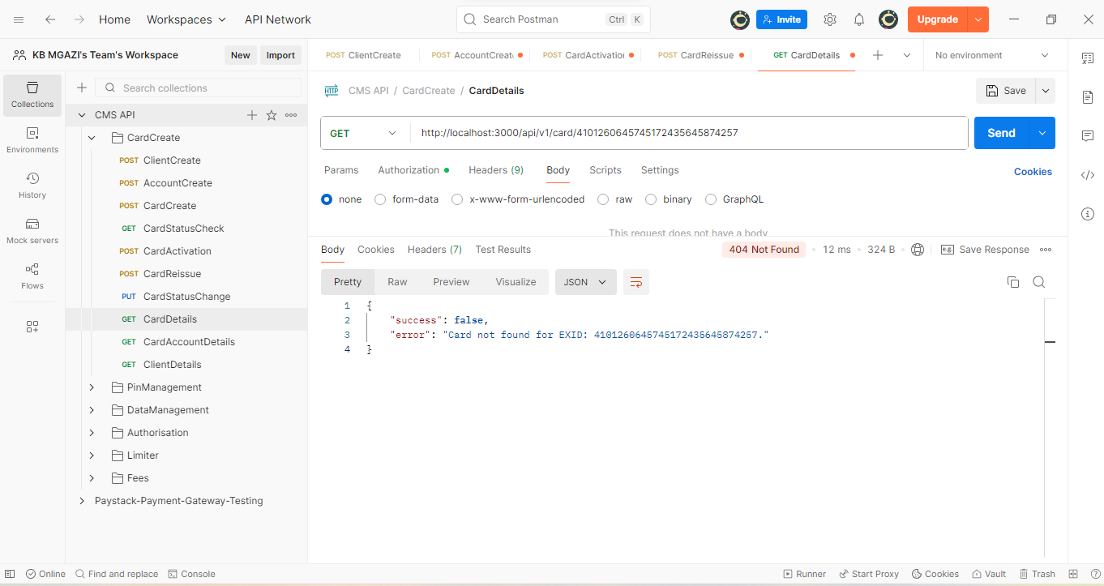
Response:
{
"success": false,
"error": "Card not found for EXID: 4101260645745172435645874257."
}

